**CSU44099 Interim Report**

**Tomas Tye 18323900** [**tyet@tcd.ie**](mailto:tyet@tcd.ie)

**"I have read and I understand the plagiarism provisions in the General Regulations of the University Calendar for the current year, found at**[**http://www.tcd.ie/calendar**](http://www.tcd.ie/calendar/)**.**

**I have also completed the Online Tutorial on avoiding plagiarism ‘Ready Steady Write’, located at**[**http://tcd-ie.libguides.com/plagiarism/ready-steady-write**](http://tcd-ie.libguides.com/plagiarism/ready-steady-write)**."**

**Section 1: Description of Planned Project**

My project, entitled ‘Measuring Synchrony in Task-Based Dialogues with Context Vectors’, is a continuation of work by my supervisor, Dr. Carl Vogel, and Justine Reverdy, namely ‘Linguistic repetitions, task-based experience and a proxy measure of mutual understanding’ and ‘Measuring Synchrony in Task-Based Dialogues’, both of which will be discussed in the literature review. The work of Vogel and Reverdy describes the development and use of an automatic method to detect engagement and synchrony in dialogue, for the purposes of advancement in natural language processing. The work I propose to do is a modification of this method, wherein in addition to considering repetition of different linguistic levels, the ‘context vectors’ of the vocabulary will also be considered.

Context Vectors:

As opposed to traditional natural language processing techniques, which treat words as atomic units, context vectors (also known as word embeddings) is a methodology to map words or phrases from a given vocabulary to a corresponding vector of real numbers, generally using neural networks. These vectors can then be compared against one another to ascertain a level of syntactic and semantic similarity between those words. Within the scope of the project, there are several different word embedding architectures to consider, with the most popular examples being Google Word2Vec, Facebook Fasttext, and Stanford’s GLoVe.

A key challenge in natural language processing has been that in human speech, the human brain has a wealth of experience that can be used as ‘metadata’ that can be used to contextualise ambiguous sentences and words. The representation of this metadata has been a foremost concern, and many attempts to ‘tag’ vocabularies with this data have fallen short in terms of efficiency when it comes to scaling towards large vocabularies. The addition of context vectors as a factor considered in the synchrony-measuring method discussed earlier is an exciting opportunity, as it allows for consideration of semantic repetition on a much deeper level, with an acceptable level of efficiency and scalability.

**Section 2: Literature Review**

Linguistic repetitions, task-based experience and a proxy measure of mutual understanding:

Reverdy & Vogel describe use of an automatic method to detect within dialogue transcripts linguistic cues of engagement and synchrony, by observing repetitions at different linguistic levels. By observing task-based dialogues, the authors can ascribe some measure of ‘success’ as the result of the dialogue, if the participants perform well in the task, it can be taken to be indicative of successful communication between them. Different levels of repetition are measured, such as repetition of inflected verb forms, repetition of lemmas, etc, as well as self-repetition and other-repetition. They are able to isolate indications of success of the method based upon their criteria, and see the method as a promising step towards quantifying engagement and understanding in dialogue using automated means.

Measuring Synchrony in Task-Based Dialogues:

Reverdy and Vogel investigate repetition as a basis of mutual understanding in dialogue, and seek to define patterns of repetition and the extent to which they interacted with external factors among dialogue participants, such as gender and familiarity of participants, and whether or not the participants were allowed to make eye contact. While they manage to produce results that seem to support the hypothesis that both self-repetition and other-repetition increase the likelihood of task success, they conclude that further exploration of the method is necessary.

Word2Vec: Efficient Estimation of Word Representations in Vector Space:

Mikolov et al. propose 2 architectures for computing continuous vector representations of words from large datasets. Upon testing, their methods find large improvements in accuracy and efficiency when compared to previously popular neural network-based natural language processing techniques.

Synchrony in Human-Bonobo Dialog:

Vogel et al. investigate claims in past research that bonobos have demonstrated capabilities of successful linguistic interaction with humans. The authors argue that the repetition displayed in human-bonobo dialogues cannot be conclusively argued to be indicative of mutual understanding.

Tracking Lexical and Syntactic Alignment in Conversation:

Howes et al. critique the evidence put forward by Pickering and Garrod (2004) that the tendency of conversational partners to match each other’s body movement, speech style and linguistic patterns (an effect known as priming) is a basic, automatic mechanism of conversational coordination. Their results indicate that the level of syntactic matching within the observed dialogue is no different than would be expected to occur by chance.

Syntactic co-ordination in dialogue:

Branigan et al. present an experiment to investigate whether speakers coordinate syntactic structure. The results clearly demonstrate this effect, which is all the more striking given form-matching was not necessary to complete the task in the task-based dialogue.

**Section 3: Project Completion Plan**

As part of the planning and design stage of my project, I have broken down the work into 4 phases:

Research Phase:

While prior to the beginning of this semester most of my work was focused on researching the background to this unfamiliar topic area, I believe there is merit to learning more about word embedding architectures, in order to properly compare their strengths and weaknesses when considering which to choose.

Implementation Phase:

The work of the implementation phase will be centred around adapting the method of Reverdy and Vogel to accommodate the addition of word embedding architectures.

Experimentation Phase:

Once the method has been adapted, work can begin on applying the new method to corpuses of task-based linguistic data in order to compare and contrast the new findings with the results of Reverdy and Vogel, under the criteria of measuring the correlation between synchrony and task success.

Deliverable Production Phase

The deliverable production phase will be centred around the creation of both the project demo and the FYP report. This is the longest phase, and informs the scheduling of the project as a whole around the submission dates for these milestones.

Controls and Communication:

The project will be undertaken under the supervision of Dr. Carl Vogel, whose work this project continues. Myself and Dr Vogel will continue to conduct weekly meetings, as we did last semester, in order to monitor progress and confer about any necessary changes to the scheduling and prioritization of project work. Minutes have been taken at all meetings thus far for posterity, and will continue to be taken.

To keep the project in check and regularly assess progress, a Gantt chart of the project schedule can be found below. A risk assessment table is also included in order to identify and attempt to mitigate roadblocks.

Gantt Chart:

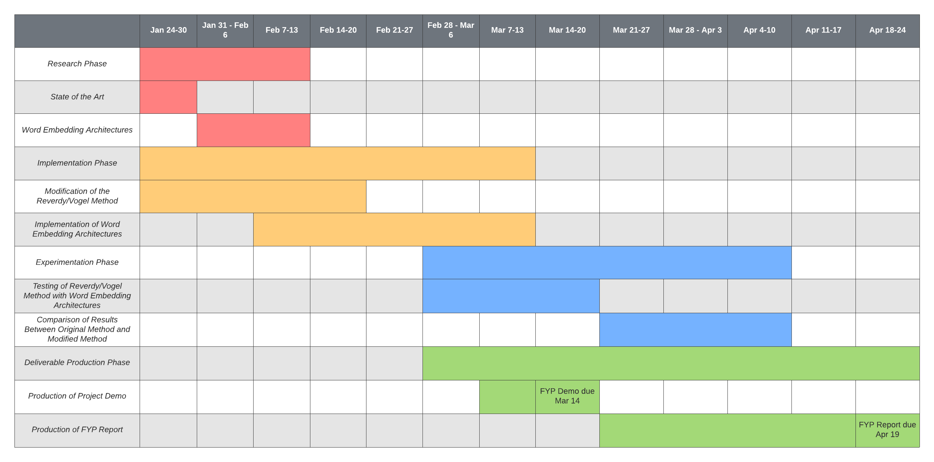

Risk Assessment Table:

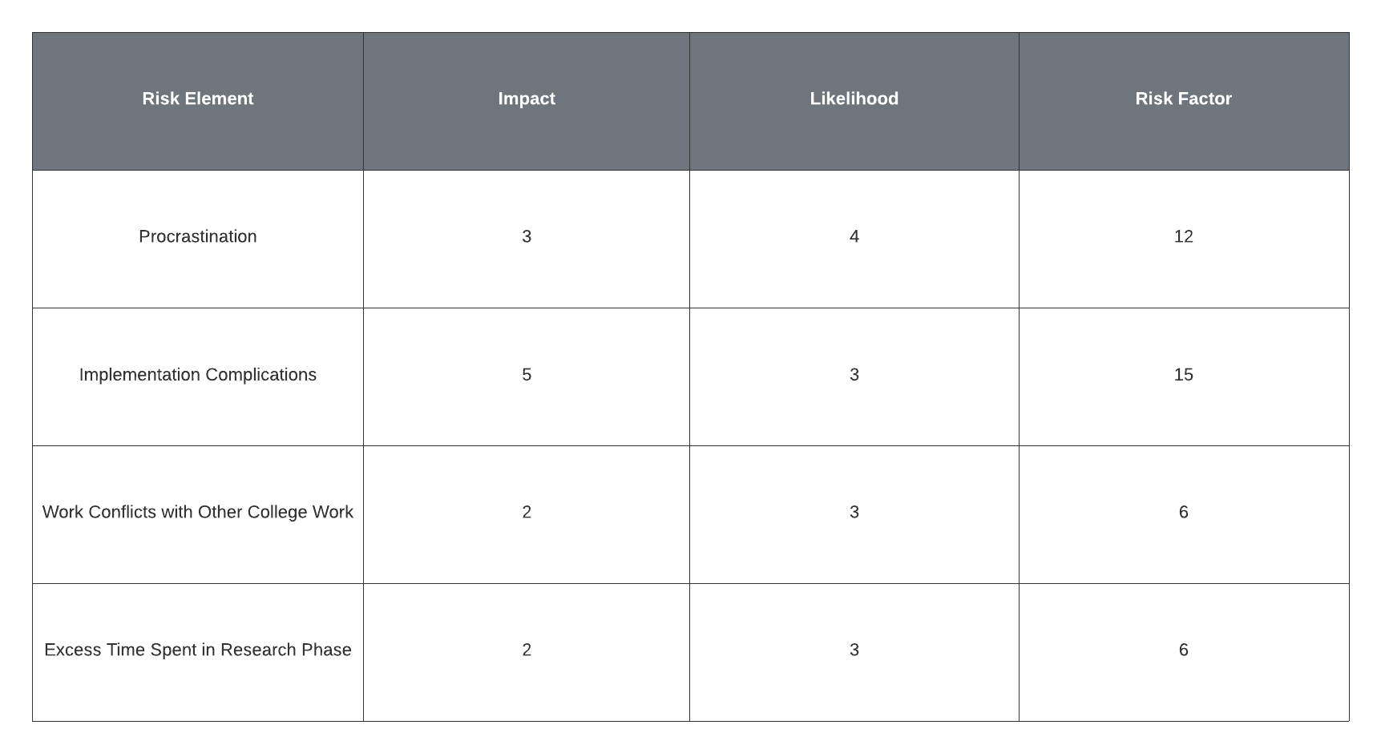

**Section 4: Ethical Considerations**

After consultation with Dr. Vogel, further collection of data to be analysed has been determined to be out of the scope of this project. It is likely that my analysis will be conducted on the HCRC Map Task Corpus. The corpus was created by the University of Glasgow, and all participants were students of the university, who fully consented to the collection and analysis of their speech data, as well as personal data relevant to the study.

**Section 5: References**

Linguistic repetitions, task-based experience and a proxy measure of mutual understanding, Reverdy and Vogel 2017, DOI: 10.1109/coginfocom.2017.8268278

Measuring Synchrony in Task-Based Dialogues, Reverdy and Vogel 2017, DOI: 10.21437interspeech.2017-1604

Deep contextualised word representations, Peters et al. 2018, arXiv: 1802.05365

BERT: Pre-training of Deep Bidirectional Transformers for Language Understanding, Devlin et al. 2018, arXiv: 1810.04805

GLoVe: Global Vectors for Word Representation, Pennington et al. 2014, DOI: 10.3114/v1/d14-1162

Word2Vec: Efficient Estimation of Word Representations in Vector Space, Mikolov et al. 2013, arXiv: 1301.3781

Synchrony in Human-Bonobo Dialog, Vogel et al., 2020, DOI: 10.1109/coginfocom50765.2020.9237906

Tracking Lexical and Syntactic Alignment in Conversation, Howes et al. 2010

Syntactic co-ordination in dialogue, Branigan et al. 2000, DOI: 10.1016/S0010-0277

Structural Priming: A Critical Review, Pickering and Ferreira, DOI: 10.1037/0033-2909.134.3.427